1. INTRODUCTION

1.1 Overview A brief description about your project

**Plugging into the Future: An Exploration of**

**Electricity Consumption Patterns**

India is the world's third-largest producer and third-largest consumer of electricity. The national electric grid in India has an installed capacity of 370.106 GW as of 31 March 2020. Renewable power plants, which also include large hydroelectric plants, constitute 35.86% of India's total installed capacity. During the fiscal year (FY) 2019–20, the total electricity generation in the country was 1,598 TWh, of which 1,383.5 TWh generated by utilities. The gross electricity consumption per capita in FY2019 was 1,208 kWh.

In 2015-16, electric energy consumption in agriculture was recorded as being the highest (17.89%) worldwide. The per capita electricity consumption is low compared to most other countries despite India having a low electricity tariff.

In light of the recent COVID-19 situation, when everyone has been under lockdown for the months of March to June the impacts of the lockdown on economic activities have been faced by every sector in a positive or a negative way.

The dataset is exhaustive in its demonstration of energy consumption state wise.

Analysing Electricity Consumption in India from Jan 2019 till 5th December 2020. This dataset contains a record of Electricity consumption in each states of India, here we are going to analyse State wise , Region wise and Overall Electricity consumption in India.

**1.2 Purpose The use of this project. What can be achieved using this.**

**Milestone 1: Define Problem / Problem Understanding**

**Activity 1: Specify the business problem**

Refer Project Description

**Activity 2: Business requirements**

The business requirements for analyzing analysis on electricity consumption in IndiaIdentify the current patterns of electricity consumption in different regions and sectors of India. This information can be used to identify areas where consumption is high and areas where it is low. Identify opportunities for improving energy efficiency and reducing consumption in different sectors and regions. This information can be used to develop policies and programs to promote energy efficiency. This information

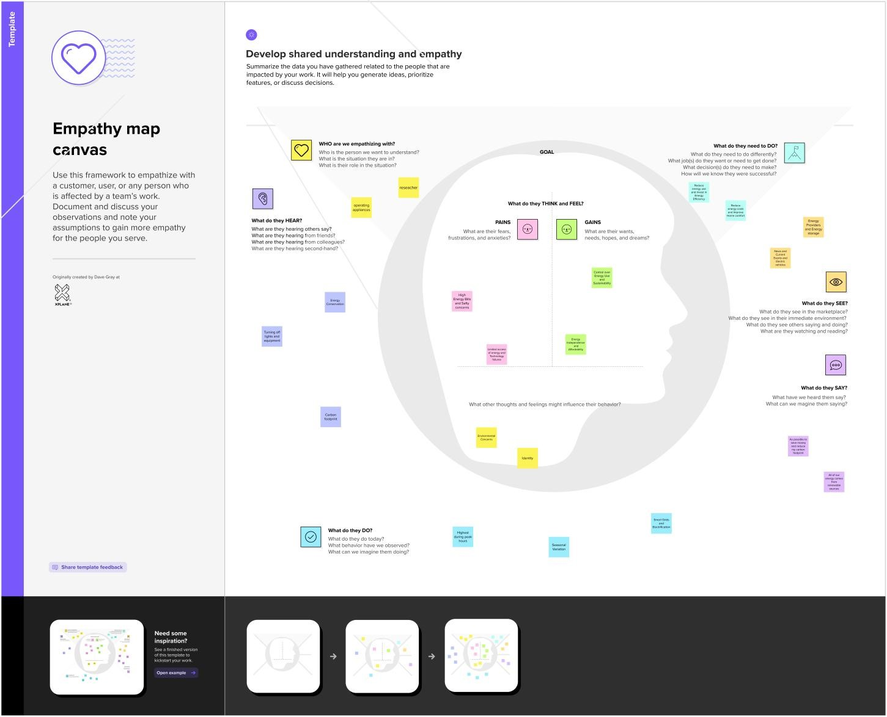

can be used by government agencies, electricity providers, and investors to develop policies and make investment decisions that promote sustainable energy development and consumption in India.

**Activity 3: Literature Survey (Student Will Write)**

A literature survey is a method of researching existing literature and studies related to a specific topic.The topic of electricity consumption in India is a well-researched area, with many studies having been conducted to understand consumption patterns and trends, as well as the impact of government policies and investment opportunities.A study by (Kumar et al., 2020) analyzed the electricity consumption patterns in India and identified the major contributors to the consumption. The study found that the residential sector was the largest consumer of electricity, followed by the commercial and industrial sectors.Another study by (Jain and Rathi, 2019) analyzed the impact of government policies on electricity consumption in India. The study found that policies promoting energy efficiency and renewable energy development have had a positive impact on reducing electricity consumption in India.

**Activity 4: Social or Business Impact.**

Social Impact: By providing access to electricity, the analysis can help to improve the quality of life for people living in areas without access to electricity, including providing access to lighting, heating, and cooling, and powering essential services such as hospitals and schools..

Business Model/Impact: By understanding consumption patterns and trends, the analysis can help businesses identify market opportunities and develop strategies to meet the growing demand for electricity in India.

2.1 Empathy Map Paste the empathy map screenshot

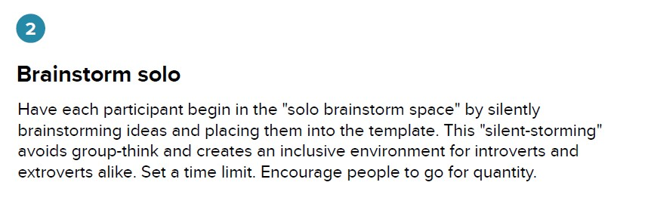

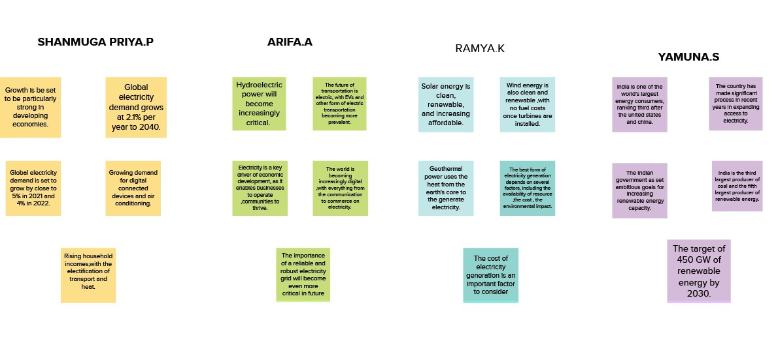

**Dashbord and story**

<https://public.tableau.com/app/profile/shanmuga.priya8585/viz/dashboard_16792705047910/Totalconsumption>

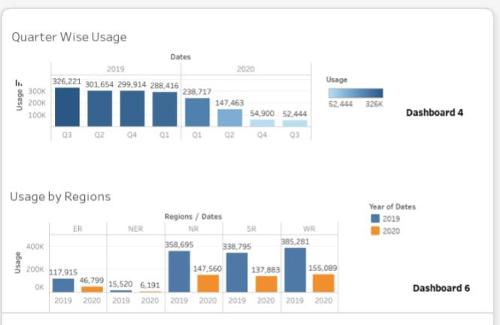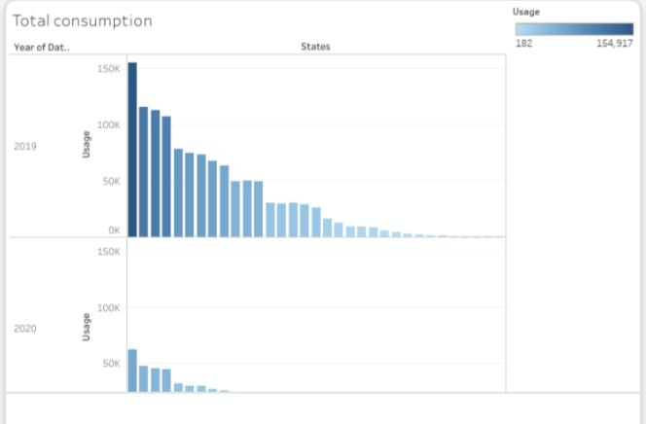

# 4 ADVANTAGES & DISADVANTAGES

**Advantages of electricity :**

* It is a clean, safe, cheap and convenient source of energy
* Lower maintenance cost
* More efficient
* No tailpipe emission
* We all know that it can be set up in many sizes
* It doesn't require as many employees
* Reduces greenhouse emission
* Makes barely any pollution compare to other ways of creating or generating electricity
* Relatively low maintenance cost
* Hydroelectric station are inexpensive to operate
* Hydroelectricity produces no gas emissions or waste
* A station can operate and run for long periods of time
* It is renewable

**Disadvantages of electricity :**

* More expensive than gasoline
* Loss of fish species
* Sometimes messes up wildlife
* Dependent on precipitation
* More power plants and more pollution
* Damming can cause loss of land suitable for agriculture as well as recreation
* Cost for construction
* Change in river or stream quality
* An electric vehicle is not completely emission free
* In electricity, there are a limited number of feasible sites for a large number of dams
* Drought can affect power production
* Hydroelectric natural seasonal changes in river and ecosystems can be destroyed

## APPLICATIONS

The areas where this solution can be applied

1-It is Used for analyzing statistic report

2-Power consumption report

3-Design and Development of EB

4-future Development for upcoming generation

# 7 FUTURE SCOPE Enhancements that can be made in the future

★ Electrical Machinery Designing Engineer

★ Electrical Equipment testing engineer

★ Chief Electrical Engineer

★ A Power Engineer

★ Power-Distribution Engineer

★ Power-Transmission Engineer

★ Electrolysis-and-Corrosion-Control Engineer

★ Electrical Cable Engineer

★ Transmission-and-Protection Engineer

★ System developer & analyst

★ Plant designing and planning officer

★ Purchase and Quality Control Executive

**8 APPENDIX**

The Edison Foundation, Institute for Electric Innovation. “Innovations Across the Grid.” December 2013.

http://www.edisonfoundation.net/iei/Documents/InnovationsAcrosstheGrid_LoRes_InstElcInnv.pdf. Accessed April 3, 2015. 2 North American Electric Reliability Corporation. “Understanding the Grid.” August 2013.

http://www.nerc.com/news/Documents/Understanding%20the%20Grid%20DEC12.pdf. Accessed March 4, 2015.

Reproduced with permission.

3 Pérez-Arriaga, I.J., H. Rudnick and M. Rivier. “Electric Energy Systems: An Overview” in “Electric Energy Systems:

Analysis and Operations.” 2008. Edited by Antonio Gomez-Exposito, Antonio J. Conejo, and Claudio Canizares. CRC

Press. As used in Massachusetts Institute of Technology Energy Initiative. “The Future of the Electric Grid.” 2011.

p. 35. http://mitei.mit.edu/publications/reports-studies/future-electric-grid. Accessed January 7, 2015. 4 Linenberger, T.R. “The Pacific Northwest-Pacific Southwest Intertie.” Bureau of Reclamation. 2013.

http://www.usbr.gov/history/ProjectHistories/PACIFIC%20NORTHWEST-

PACIFIC%20SOUTHWEST%20INTERTIE%20MASTER%20ZLA%20HC%20FC%20BC%20IC%20SC%207.2010.pdf. Accessed April 3,

2015.

5 Energy Information Administration. “Form 861 data files.” February 19, 2015.

http://www.eia.gov/electricity/data/eia861/index.html. Accessed February 26, 2015. 6 Energy Information Administration. "What is the electric power grid and what are some challenges it faces?" Energy in Brief.

September 16, 2014. http://www.eia.gov/energy_in_brief/article/power_grid.cfm. Accessed January 15, 2015. 7 Edison Electric Institute. “EEI Statistical Yearbook 2013.” Table 10.6. 2013. 8 Platts . “UDI Directory of Electric Power Producers and Distributors, 123nd Edition of the Electrical World Directory.” p. vi.

2014.

https://www.platts.com/IM.Platts.Content/downloads/udi/eppd/eppddir.pdf.https://www.platts.com/IM.Platts.Content/down

loads/udi/eppd/eppddir.pdf. Accessed May 26, 2015. 9 National Academy of Engineering. “Greatest Engineering Achievements of the 20th Century.” 2000.

http://www.greatachievements.org/. Accessed January 5, 2015. 10 Energy Information Administration. “Monthly Energy Review: Table 7.3b: Consumption of Combustible Fuels for Electricity

Generation.” p. 110. February 2015. http://www.eia.gov/totalenergy/data/monthly/pdf/sec7_10.pdf. Accessed March 20,

2015.

11 Energy Information Administration. “Annual Energy Outlook 2014.” Table 135. May 2014.

http://www.eia.gov/forecasts/archive/aeo14/tables_ref.cfm. Accessed February 25, 2015. 12 Energy Information Administration. “Monthly Energy Review.” Table 7.2a. p. 97. January 2015.

http://www.eia.gov/totalenergy/data/monthly/archive/00351501.pdf. Accessed February 25, 2015. 13Energy Information Administration. “U.S. Natural Gas Consumption by End-Use.”

http://www.eia.gov/dnav/ng/ng_cons_sum_dcu_nus_a.htm. Accessed March 4, 2015. 14 Energy Information Administration. "Half of power plant capacity additions in 2013 came from natural gas." Today in Energy.

April 8, 2014. http://www.eia.gov/todayinenergy/detail.cfm?id=15751. Accessed January 21, 2015. 15 Energy Information Administration. "Natural gas, solar, and wind lead power plant capacity additions in first-half 2014."

Today in Energy. September 9, 2014. http://www.eia.gov/todayinenergy/detail.cfm?id=17891. Accessed February 2, 2015. 16 Tobin, J. "Expansion and Change on the U.S. Natural Gas Pipeline Network 2002." Natural Gas Analysis Publications. 2002.

http://www.eia.gov/pub/oil_gas/natural_gas/feature_articles/2003/Pipenet03/pipenet03.html. Accessed January 15, 2015. 17 Energy Information Administration. “Annual Energy Outlook 2014.”Figure MT-29. May 7, 2014. 18 Faruqui, A. “Surviving Sub-One Percent Sales Growth.” The Brattle Group. March 20, 2014.

http://www.brattle.com/system/publications/pdfs/000/004/988/original/Surving_Sub_One_Percent_Sales_Growth_Faruuqui_

3_13_2014.pdf?1394816248. Accessed April 3, 2015. 19 Wood, L. and R. Borlick. “Value of the Grid to DG Customers.” Institute for Electric Innovation Issue Brief. October 2013.

http://www.edisonfoundation.net/iei/Documents/IEE_ValueofGridtoDGCustomers_Sept2013.pdf. Accessed April 3, 2015. 20 Energy Information Administration. “Annual Energy Outlook 2015.” April 2015.

http://www.eia.gov/forecasts/aeo/tables_ref.cfm. Accessed May 4, 2015. 21 American Wind Energy Association. “U.S. Wind Industry Fourth Quarter 2014 Market Report.” January 28, 2015.

http://awea.files.cms-plus.com/4Q2014%20AWEA%20Market%20Report%20Public%20Version.pdf. Accessed May 5, 2015.